The ability to accurately assess one’s memory ability is critical so individuals can adjust their study strategies for future learning. A common method for assessing this relationship in empirical settings is by having individuals provide metacognitive judgments at the time of study by providing judgements of learning (JOLs). In this task, participants study a memory set, such as paired-associates (e.g., bank-loan), and are asked to rate how likely they would be able to recall the target word if presented with the cue at test (e.g., bank-____) using a 0-100 rating scale in which higher numbers indicate greater confidence that the target word will be correctly recalled at test. JOLs therefore allow researchers to determine the correspondence between a provided JOL rating and later recall accuracy.

Prior work by Koriat and Bjork (2005) has shown that JOL accuracy can be directly influenced by the relationships present between the stimuli pairs. Specifically, they manipulated the direction of the associative overlap between item pairs (i.e., the likelihood that a cue is related to a target) to examine how the direction of the relationship influenced JOL ratings relative to test performance. By examining the relationship between JOLs and subsequent recall for forward and backward associates (e.g., credit-card vs. card-credit), a pattern emerged in which predicted JOLs were similar to later recall accuracy for forward-associative pairs (i.e., well-calibrated), but an *illusion of competence* occurred for backward-associative pairs in which JOLs overpredicted later recall.

Additional research conducted by Castel, McCabe, and Roediger (2007) extended this work to include identical item pairs (e.g., credit-credit) as a means of testing the influence of item similarity on JOL accuracy and achieved similar results. However, some concerns arise with the use of identical item pairs. First, these pairs share no associative overlap as word associations, by definition, are formed through the repeated use of different (vs. same) words in natural language. Second, normed databases like the South Florida Free Association Norms (Nelson, McEvoy, & Schreiber, 2004) do not contain entries for identical pairs. Finally, the use of identical pairs introduces other confounds such as effects of repetition priming and complete overlap of semantic features which could affect JOLs outside of one’s metamemory ability.

In the present study, we sought to address these potential limitations by examining the correspondence between JOLs and recall accuracy using symmetrical associates (e.g., on-off). The advantage of symmetrical associates is that the items share associative overlap, making them comparable to forward and backward associates when using word association norms. Therefore, our study was able to closely examine the associative direction between word pairs (either forward, backward, or symmetrical) while controlling for associative strength.

In Experiment 1, participants studied a set of 80-word pairs comprised of forward, backward, symmetrical, and unrelated (e.g., cat-building) pairs followed by a cued-recall test. Study timing was self-paced and participants provided JOLs while the word pairs were on the screen. Replicating Koriat and Bjork’s (2005), JOLs for forward pairs were well-calibrated to later cued-recall, however JOLs greatly exceeded cued-recall for backward pairs. JOLs similarly overpredicted cued-recall for both symmetrical associates and unrelated pairs, though to a lesser degree. To further investigate JOL estimations on later cued-recall, we constructed novel calibration plots in which JOLs ratings were plotted against their corresponding recall accuracy (see Roediger, Wixted, & Desoto, 2012 for similar plots with test-based confidence ratings). Figure 1 shows that JOL overestimations occurred for backward and unrelated pairs across all recall rates, but overestimations only occurred for forward and symmetrical pairs when recall rates were high (60-100%). These analyses therefore show association that strength and direction affect illusions of competence but that the illusion is moderated by the relative recall rate.

In Experiment 2, we further examined word pair associations on JOL accuracy by more closely controlling for encoding duration across pair types versus self-paced study in Experiment 1. Study duration was unequal across pair types ranging from 3924 ms (*SD* = 2653 ms) for unrelated pairs to 4749 ms (*SD* = 3650 ms) for backward pairs with a high level of variability. Therefore, a deadline of 5000 ms was used in Experiment 2 for participants to study the word pair and provide a JOL rating. We expected that this encoding duration would result in a more pronounced overestimation effect as less time spent at encoding should lead to greater recall inaccuracies across pair types.

Interestingly, results from Experiment 2 were largely consistent with Experiment 1. JOLs correctly estimated recall for forward pairs, but overestimated recall for backward, symmetrical, and unrelated pairs. The calibration plots indicated that overestimations occurred across recall rates for backward and unrelated pairs but again only were found for forward and symmetrical pairs when recall rates were relatively high. Thus, forward pairs again seem to be resistant to illusions of competence even with limited time allocated for study and judgment making.

Collectively, our experiments indicated that JOLs are often discrepant with later cued-recall, with individuals largely overestimating recall accuracy. Calibration plots indicated that even forward associates, which appear to be immune to overestimates when analyzing overall JOLs and cued-recall accuracy, yield overestimates when recall accuracy is high. Therefore, further research should focus on different techniques that may reduce these overestimation effects and produce more calibrated JOLs. For instance, research has indicated that JOL accuracy can be improved when JOLs are elicited after a delay and not made at the same time the pair is presented (Nelson & Dunlosky, 1991). Additionally, methods that may improve overall recall rates to match participant’s typical lofty JOL estimates, such as using “deep” encoding tasks, may also improve JOL/recall calibration. We are currently evaluating these possibilities to determine which methods best improve metamemorial accuracy.

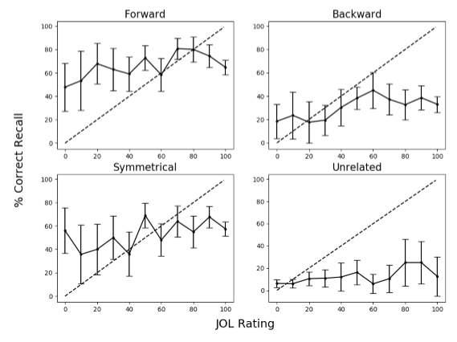

*Figure 1.* Mean percent correct recall for each JOL level for forward, backward, symmetrical, and unrelated pair types in Experiment 1. The dashed line indicates perfect calibration between JOL ratings and cued-recall. Overconﬁdence is represented by points falling below the calibration line. Bars indicated 95% CIs.

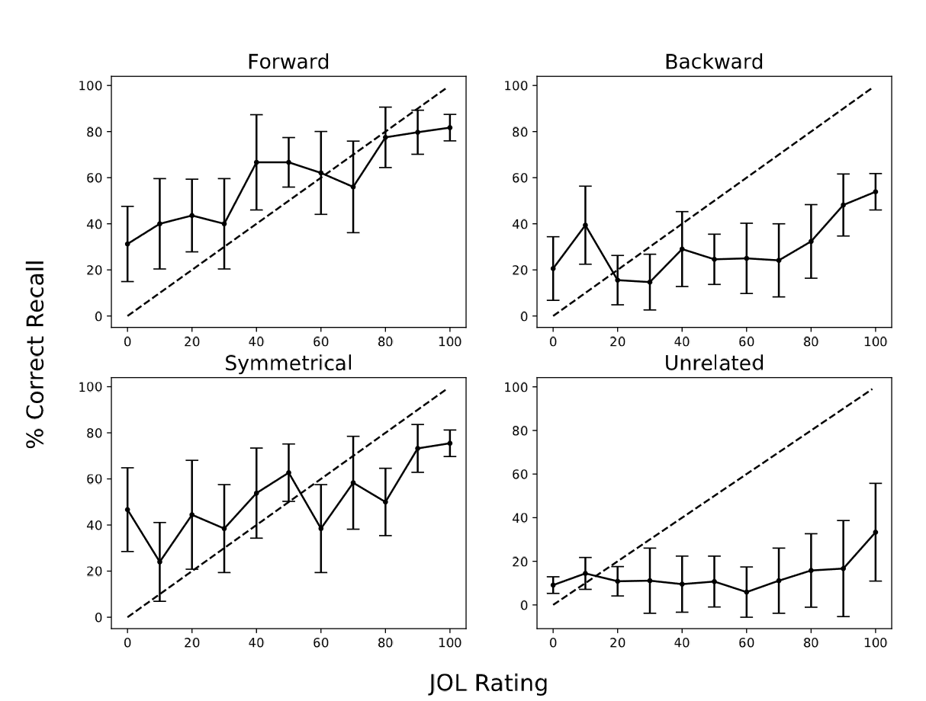

*Figure 2.* Mean percent correct recall for each JOL level for forward, backward, symmetrical, and unrelated pair types in Experiment 2. The dashed line indicates perfect calibration between JOL ratings and cued-recall. Overconﬁdence is represented by points falling below the calibration line. Bars indicated 95% CIs.

**References**

Castel, A. D., McCabe, D. P., & Roediger, H. L. (2007). Illusions of competence and overestimation of associative memory for identical items: evidence from judgments of learning. *Psychonomic Bulletin & Review, 14*(1), 107–111. doi:10.3758/BF03194036

Koriat, A., & Bjork, R. A. (2005). Illusions of competence in monitoring one’s knowledge during study. *Journal of Experimental Psychology: Learning, Memory, and Cognition, 31*(2), 187–194. doi:10.1037/0278-7393.31.2.187

Koriat, A., & Bjork, R. A. (2006). Illusions of competence during study can be remedied by manipulations that enhance learners’ sensitivity to retrieval conditions at test. *Memory & Cognition*, *34*(5), 959–927.

Nelson, D. L., McEvoy, C. L., & Schreiber, T. A. (2004). The University of South Florida free association, rhyme, and word fragment norms. *Behavior Research Methods, Instruments, & Computers, 36*(3), 402–407. doi:10.3758/BF03195588

Nelson, T. O., & Dunlosky, J. (1991). When people’s judgments of learning (JOLs) are extremely accurate at predicting subsequent recall: The delayed-JOL eﬀect. *Psychological Science*, *2*, 267–270.

Roediger, H. L., Wixted, J. T. & DeSoto, K. A. (2012). The Curious Complexity between Confidence and Accuracy in Reports from Memory. In Nadel, Lynn, and Sinnott-Armstrong, Walter, (Eds.). *Memory and Law*. Oxford University Press, New York

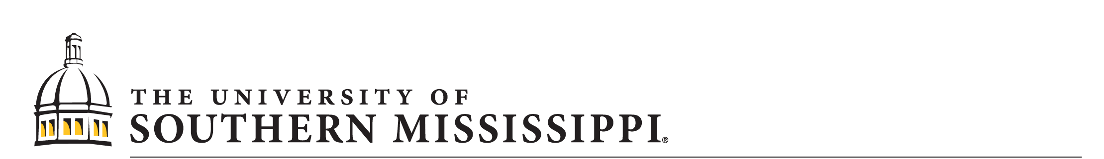

SCHOOL OF PSYCHOLOGY

118 College Drive #5025 | Hattiesburg, MS 39406-0001

Phone: 601.266.5411 | Fax: 601.266.5580 | mark.huff@usm.edu | www.usm.edu

April 14, 2019

Psychonomic Society

2424 American Lane

Madison, WI 53704-3102

Dear Graduate Travel Award Section Committee:

With great pleasure I am writing this letter on behalf of Nicholas Maxwell to support his travel to the 2019 Psychonomic Society meeting in Montreal, QC, Canada. Nick is currently pursuing a PhD in Cognitive Psychology in my lab at The University of Southern Mississippi and this award will greatly assist Nick in attending this year’s conference. In addition to providing Nick with the opportunity to present his research, this award will greatly help with his educational development and afford him critical networking opportunities as he seeks a career as an academic in the Cognitive Sciences.

Nick is fully eligible for this award: He is currently a graduate student who is enrolled in our PhD program and will be the first author presenter on his submitted poster. Additionally, I am a Fellow of the society and will be sponsoring his submission to the conference. As you will see from Nick’s submission, he did a fine job in preparing a brief research summary for the project and preparing an abstract for the conference. I can verify that Nick’s submission is entirely his own. I am very proud of Nick’s efforts on this project and I hope that you find his application suitable for funding for this year’s conference.

If you have any questions about Nick’s conference submission or his application, please do not hesitate to contact me following my contact information below.

Sincerely,

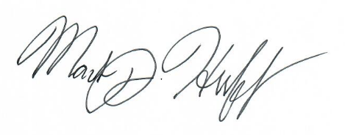

Mark J. Huff, PhD

Assistant Professor, Psychology

The University of Southern Mississippi

601.266.5411

mark.huff@usm.edu